

**Stock market prediction using RNN-GRU and LSTM Techniques**

# UNIVERSITY OF HERTFORDSHIRE

School of Physics, Engineering, and Computer Science

Bokkala Shravan Kumar :19057016

15 July 2022

**Course:** 7COM1039-0509-2021 - Advanced Computer Science Masters Project

**Student name:** Bokkala Shravan Kumar

**Student Name:** 19057016

**Supervised by:** Luke Wood

Table of Contents

Introduction 3

Research Questions 4

Dataset Details 4

Features and Terminology 4

Software apparatus 4

Background of the Research 5

Summary of progress to date 7

Project plan 8

Social, ethical and legal issues 10

References 11

Appendices 1 13

Appendices 2 16

Appendices 3 26

# **Introduction**

Since the approach of the socialist market economy, the currency market has played an indispensable capability all over the world. Lately, with the advancement of the public economic framework and the improvement of economic administrations, the financial market has drawn light a legitimate concern for homegrown and unfamiliar dealers and purchasers. Analysts frequently concoct a wide range of hypotheses that can be applied practically speaking to foresee market developments. Notwithstanding, as the market is impacted by public strategies and the worldwide economy and encompasses the economy alongside mental, human, and different variables, monetary market gauges frequently neglect to accomplish the ideal outcomes.

Because of different examinations, neural networks have been utilized in numerous areas including pattern recognition, financial protection, and character handling. Besides, it has acquired wide notoriety because of its regression and class benefits in financial exchange forecasts. However, in addition, conventional neural network architectures may not precisely foresee the equity markets because of the predominance of random sampling difficulty, which easily falls on local peaks, leading to inaccurate predictions. In recent years, each major device for deep learning acquisition and new predictive models has undergone rapid development. With programming apps constantly improving, it's easier to deploy and verify deep learning solutions. Recently, artificial neural networks using multiple information graphs are emerging as a successful idea. The investigation of stock market figures isn't restricted to the scholarly world. Resource the executive's firms and investment banks, baited by the expected income from stock exchanges filled by stylish deep learning models, are additionally extending their exploration gifts to artificial intelligence, communicated in the present in trendy deep learning structure.

Also, we give close consideration to the performance and reproducibility of past research, which will be neglected in near examinations. The list of open records and the distributed archive code will most likely not just assist readers with confirming the legitimacy of their decisions yet additionally present these default models and genuinely assess whether the informational indexes might come as indistinguishable.

# **Research Questions**

RQ1: What are the issues and challenges of stock market prediction?

RQ2: How accurate are LSTM and GRU-RNN to predict the stock market?

RQ3: How accurate the model can predict in the case of the power sector or banking sectors?

# **Dataset Details**

The historical data of the stock value data is freely accessible and it's open source it very well may be gotten to by anybody. For my current use case, to get the required S&P 500 stock index history from the Yahoo finance database I am using the pandas DataReader library. I will utilize the features like open, close, adjusted price and volume, etc., which are also available. To extract the information in the pandas' data frame I am using a utility function called getraw_data(). This function takes the input as the index ticker name. The ticker name for S&P 500 index is ^GSPC.

## **Features and Terminology**

In the stock market, the high and low allude to the max and min costs in a given period. Open and close are the costs at which a stock started and finished exchanging a similar period. Volume is the aggregate sum of exchanging movement. Changed values consider corporate activities like profits, stock parts, and new offer issuance.

## **Software apparatus**

**Anaconda Navigator** is a UI (UI) that permits engineers to send off various packages, libraries, and applications. It's an option of pip packages which is additionally utilized for a similar reason; however, pip utilized the command-line interface (Embarak, 2018). That is the reason numerous engineers incline Anaconda Navigator for setting environments and introducing various libraries.

In this project, I am using Jupyter Notebook for the implementation of any machine learning problems, visualization of results, and statistical problems because it is an open-source web-based application and it provides a user interface like an integrated development environment (IDE) (Randles, et al., 2017). It is a lightweight application and very useful for large datasets.

For most of the machine learning and data science-related fields python language is the most popular language used by everyone. I am also using this language for implementing stock prediction models and for visualization purposes. The main reason why I am preferring python was it provides many built-in packages and libraries (Wikipedia, 2020).

# **Background of the Research**

(Parmar, et al., 2018) determined the future prices of the stocks of a company with greater accuracy by using the regression and LSTM models. They compared both models in a practical approach, the LSTM model gave better results than the regression model.

(Damrongsakmethee, et al., 2020) designed the architectural structure of the deep learning model using eleven LSTM layers and chose the ADAM optimization tool for better forecasting. Their test results show the LSTM model has predicted accurate results compared to other research performances.

(Nabipour, et al., 2020) this study compares nine machine learning models and two powerful deep learning models to predict the stock price of four stock groups from the Tehran stock exchange. Their experiment showed that there was a significant improvement in the performance of models when they use binary data instead of continuous one. Indeed, deep learning models showed better results in both binary and continuous data.

(Biswas, et al., 2021) used LSTM, Extreme gradient boosting, linear regression, and moving average on more than one year of historical stock data of the Dhaka stock exchange to build up a prediction model for forecasting stock price. They compared those models by taking measurements such as mean absolute percentage error. they found that the LSTM model performed better than other models.

(Nabipour, et al., 2020) this paper concentrates on the future prediction of four stock groups in the Tehran stock exchange for one month in advance by using six machine learning and two deep learning models. After employing all those models, the researchers concluded that LSTM shows more accurate results with the highest model fitting ability.

(Mondal, et al.,2020) proposed a combined effort of using four machine learning with the LSTM model to predict the future stock price of four stock groups in the national stock exchange. After employing all models, they concluded that the LSTM model predicted good results with better accuracy, they also mentioned that LSTM eliminates vanishing gradient problems partially.

(Althelaya, et al., 2018) this study evaluates and compares two LSTM deep learning architectures for short-term and long-term prediction of stock prices, for this they used stacked and bidirectional LSTM models on S&P 500 stocked index data. The results showed that the BLSTM showed better results than the SLSTM model.

(Sunny, M.A.I., et al.,2020) proposed LSTM and BLSTM models to predict the future forecast of the stock price of google stock market. They said to develop any kind of prediction model adjustment of parameters is very important as the accuracy in prediction depends significantly on these parameters. In the results, the BLSTM showed more accuracy than the other model.

(Agrawal, et al., 2019) proposed the LSTM model and Adaptive stock technical indicators to predict the closing price of the three financial organizations in the national stock exchange of India. They compared the results with two benchmark machine learning classifiers and analyzed them using popular metrics, the mean prediction accuracy achieved using LSTM is 59.25%.

(Lakshminarayanan, et a., 2019) this is a comparative study of the performance of the LSTM model with the SVM model. In this study performance of the models is measured by root mean squared error, mean squared error, mean absolute error, mean absolute percentage error, and r square error. overall LSTM gives more accuracy than the SVM in all scenarios.

(Hiransha, et al., 2018) in this study, they used four types of deep learning architectures like multilayer perception, recurrent neural network, LSTM, and CNN to predict the future price of NSE over 15-30 days. After deploying all models, they concluded as the CNN model performed better results and it is capable of capturing the abrupt changes in the system.

(Li, J., et al., 2017) investigated investors’ sentiment as measured from a large collection of data from posts posted on stock forums is predictive of CSI index value. First, they deployed a naïve Bayes classifier to assign all posts on stock forums to three classes (positive, negative, and neutral) then they developed the LSTM model for future prediction.

(Srivastava, et al., 2022) investigated multiple modes, including LSTM and ARIMA modes, which may be interesting for time collection data. Furthermore, the research found that ARIMA is one of the best stock market valuation methods for time series. This version was based on historical data. This model provided more accurate and quality results than any other model.

(Javed, et al., 2021) performed logistic regression and Naive Bayes classifiers. Experimental results show that linear regression, random forest, and general linear regression provide accuracy from 80% to 98%. Decision tree-based test results are not so accurate for predicting the stock market.

# **Summary of progress to date**

# 

# Firstly, as I defined in the proposal my first task is select the energy or banking sector index for the analysis. As per the plan and goal of this research, I have studied some research papers as a part of the literature review and then I started investigating HSBC stock and its historical data from yahoo finance.

I have selected two companies SHELL PLC and NGL Energy Partners LP as power or energy sector-based companies and HSBC and HDFC as banking sectors for our evaluation. Next, I used pandas_datareader and the yahoo finance module to fetch data directly with an API call directly from the jupyter notebook. The data has been collected and explored in many ways comparing each other based on daily return, moving average, closing price, the volume of trade, etc.

# **Project plan**

In the next part of the analysis, I will define the model of LSTM and GRU-RNN to predict the stock of HSBC. I will also use the same procedure to incorporate the other three companies I have selected. I plan to fetch out the last 60 days' record and predict the stock opening and closing very current day of evaluation of the program.

|  |  |  |  |  |  |  |  |  |  |  |  |  |  |  |  |  |  |  |  |  |  |  |  |  |  |  |  |
| --- | --- | --- | --- | --- | --- | --- | --- | --- | --- | --- | --- | --- | --- | --- | --- | --- | --- | --- | --- | --- | --- | --- | --- | --- | --- | --- | --- |
| Tasks | Tasks Name | Duration | | Start Date | | End date | |  |  | |  | |  | |  | |  | |  | |  | |  | |  |  |  |
|  | **Stock market prediction** | 83 | | 09-Jun | | 03-Sep | |  |  | |  | |  | |  | |  | |  | |  | |  | |  |  |  |
| 1 | Proposal of the project | 3 | | 09-Jun | | 11-Jun | |  |  | |  | |  | |  | |  | |  | |  | |  | |  |  | |
| 2 | **Introduction** | 20 | | 12-Jun | | 01-Jul | |  |  | |  | |  | |  | |  | |  | |  | |  | |  |
| 3 | Research aims and objectives | 6 | | 12-Jun | | 17-Jun | |  |  | |  | |  | |  | |  | |  | |  | |  | |  |
| 4 | problem statement | 5 | | 18-Jun | | 22-Jun | |  |  | |  | |  | |  | |  | |  | |  | |  | |  |
| 5 | Proposed solution | 5 | | 23-Jun | | 27-Jun | |  |  | |  | |  | |  | |  | |  | |  | |  | |  |
| 6 | Expected output | 4 | | 28-Jun | | 01-Jul | |  |  | |  | |  | |  | |  | |  | |  | |  | |  |
| 7 | **Research** | 14 | | 02-Jul | | 15-Jul | |  |  | |  | |  | |  | |  | |  | |  | |  | |  |
| 8 | Background research | 4 | | 02-Jul | | 05-Jul | |  |  | |  | |  | |  | |  | |  | |  | |  | |  |
| 9 | Literature Review and Paper Studied | 8 | | 06-Jul | | 13-Jul | |  |  | |  | |  | |  | |  | |  | |  | |  | |  |
| 10 | Literature Conclusion | 2 | | 14-Jul | | 15-Jul | |  |  | |  | |  | |  | |  | |  | |  | |  | |  |
| 11 | **Methodology** | 15 | | 16-Jul | | 30-Jul | |  |  | |  | |  | |  | |  | |  | |  | |  | |  |
| 12 | Research Scope | 5 | | 16-Jul | | 20-Jul | |  |  | |  | |  | |  | |  | |  | |  | |  | |  |
| 13 | Project Methodology | 5 | | 21-Jul | | 25-Jul | |  |  | |  | |  | |  | |  | |  | |  | |  | |  |
| 14 | Architectural Strategies | 5 | | 26-Jul | | 30-Jul | |  |  | |  | |  | |  | |  | |  | |  | |  | |  |
| 15 | **Predicting Model** | 20 | | 31-Jul | | 19-Aug | |  |  | |  | |  | |  | |  | |  | |  | |  | |  |
| 16 | Data collection | 4 | | 31-Jul | | 03-Aug | |  |  | |  | |  | |  | |  | |  | |  | |  | |  |
| 17 | Data analysis and pre-processing | 5 | | 04-Aug | | 08-Aug | |  |  | |  | |  | |  | |  | |  | |  | |  | |  |
| 18 | Visualizing risk factors | 4 | | 09-Aug | | 12-Aug | |  |  | |  | |  | |  | |  | |  | |  | |  | |  |
| 19 | Creating models for GRU-RNN and LSTM | 7 | | 13-Aug | | 19-Aug | |  |  | |  | |  | |  | |  | |  | |  | |  | |  |
| 20 | **Deployment and testing** | 15 | | 20-Aug | | 03-Sep | |  |  | |  | |  | |  | |  | |  | |  | |  | |  |
| 21 | Analyze the results | 5 | | 20-Aug | | 24-Aug | |  |  | |  | |  | |  | |  | |  | |  | |  | |  |  |  |
| 22 | Comparison and discussion | 3 | | 25-Aug | | 27-Aug | |  |  | |  | |  | |  | |  | |  | |  | |  | |  |  |  |
| 23 | Conclusion | 3 | | 28-Aug | | 30-Aug | |  |  | |  | |  | |  | |  | |  | |  | |  | |  |  |  |
| 24 | References | 2 | | 31-Aug | | 01-Sep | |  |  | |  | |  | |  | |  | |  | |  | |  | |  |  |  |
| 25 | Appendices | 2 | | 02-Sep | | 03-Sep | |  |  | |  | |  | |  | |  | |  | |  | |  | |  |  |  |
|  |  |  | |  | |  | |  |  | |  | |  | |  | |  | |  | |  | |  | |  |  |  |
|  |  |  | |  | |  | |  |  | |  | |  | |  | |  | |  | |  | |  | |  |  |  |
|  |  |  | |  | |  | |  |  | |  | |  | |  | |  | |  | |  | |  | |  |  |  |
|  |  |  | |  | |  | |  |  | |  | |  | |  | |  | |  | |  | |  | |  |  |  |
|  |  |  | |  | |  | |  |  | |  | |  | |  | |  | |  | |  | |  | |  |  |  |
|  |  |  | |  | |  | |  |  | |  | |  | |  | |  | |  | |  | |  | |  |  |  |
|  |  |  | |  | |  | |  |  | |  | |  | |  | |  | |  | |  | |  | |  |  |  |
|  |  |  |  | |  | |  |  | |  | |  | |  | |  | |  | |  | |  | |

# **Social, ethical and legal issues**

Predicting stock index volatility is considered a difficult task as forecasting stock financials depends on time. Correctly predicting stock price movements can be profitable for buyers. Due to the complexity of stock market statistics, the development of correct predictions is very difficult. Stock market predictions have a huge social affect on the stock market, whether it's falling stock prices or the growing investment stock. An investor who chooses to invest in a stock based on this research might lead to loss or failure which will be unethical as it is uncertain. Ethical investing seeks to help industries with great impact, including sustainable solutions and generates funds in return. Therefore, it will also depend on the completion or failure of research and engineering. Ethical investing provides a character with the energy to allocate capital to agencies whose practices and values ​​align with ideals. Some ideals are rooted in ecological, spiritual, or political precepts. Predicting the market is difficult because fate as well, inherently unpredictable, but it is also not a crime. Stock market manipulation is in most cases illegal, but it is difficult for regulators and various authorities to detect and prove.

The dataset I have used in the project is gathered from the open-source website called yahoo finance. It is free and it can be accessed by everyone. So, there is no intervention of legal issues. As it is a stock market dataset it is used purely for prediction purposes and not for any other intentions.

As I am not involving any people in any structure or shape or for any connections concerning my project there would be no moral issues in regards to this task. I followed all the university rules and followed every guideline to make this project. As to the project, I am not putting any individuals in a terrible mood or feelings.

# **References**

Li, X., Wu, P. and Wang, W., 2020. Incorporating stock prices and news sentiments for stock market prediction: A case of Hong Kong. *Information Processing & Management*, *57*(5), p.102212.

Parmar, I., Agarwal, N., Saxena, S., Arora, R., Gupta, S., Dhiman, H. and Chouhan, L., 2018, December. Stock market prediction using machine learning. In *2018 first international conference on secure cyber computing and communication (ICSCCC)* (pp. 574-576). IEEE.

Damrongsakmethee, T. and Neagoe, V.E., 2020, June. Stock market prediction using a deep learning approach. In *2020 12th International Conference on Electronics, Computers and Artificial Intelligence (ECAI)* (pp. 1-6). IEEE.

Nabipour, M., Nayyeri, P., Jabani, H., Shahab, S. and Mosavi, A., 2020. Predicting stock market trends using machine learning and deep learning algorithms via continuous and binary data; a comparative analysis. *IEEE Access*, *8*, pp.150199-150212.

Biswas, M., Shome, A., Islam, M.A., Nova, A.J. and Ahmed, S., 2021, April. Predicting stock market price: A logical strategy using deep learning. In *2021 IEEE 11th IEEE Symposium on Computer Applications & Industrial Electronics (ISCAIE)* (pp. 218-223). IEEE.

Nabipour, M., Nayyeri, P., Jabani, H., Mosavi, A. and Salwana, E., 2020. Deep learning for stock market prediction. *Entropy*, *22*(8), p.840.

Mondal, S., Dutta, A. and Chatterjee, P., 2020, February. Application of Deep Learning Techniques for Precise Stock Market Prediction. In *Proceedings Of The 3 rd National Conference On Machine Learning And Artificial Intelligence (NCMLAID’20)*.

Althelaya, K.A., El-Alfy, E.S.M. and Mohammed, S., 2018, April. Evaluation of bidirectional LSTM for short-and long-term stock market prediction. In *2018 9th international conference on information and communication systems (ICICS)* (pp. 151-156). IEEE.

Sunny, M.A.I., Maswood, M.M.S. and Alharbi, A.G., 2020, October. Deep learning-based stock price prediction using LSTM and bi-directional LSTM model. In *2020 2nd Novel Intelligent and Leading Emerging Sciences Conference (NILES)* (pp. 87-92). IEEE.

Agrawal, M., Khan, A.U. and Shukla, P.K., 2019. Stock indices price prediction based on technical indicators using deep learning model. *International Journal on Emerging Technologies*, *10*(2), pp.186-194.

Lakshminarayanan, S.K. and McCrae, J.P., 2019, December. A Comparative Study of SVM and LSTM Deep Learning Algorithms for Stock Market Prediction. In *AICS* (pp. 446-457).

Hiransha, M., Gopalakrishnan, E.A., Menon, V.K. and Soman, K.P., 2018. NSE stock market prediction using deep-learning models. *Procedia computer science*, *132*, pp.1351-1362.

Althelaya, K.A., El-Alfy, E.S.M. and Mohammed, S., 2018, April. Stock market forecast using multivariate analysis with bidirectional and stacked (LSTM, GRU). In *2018 21st Saudi Computer Society National Computer Conference (NCC)* (pp. 1-7). IEEE.

Li, J., Bu, H. and Wu, J., 2017, June. Sentiment-aware stock market prediction: A deep learning method. In *2017 international conference on service systems and service management* (pp. 1-6). IEEE.

Javed Awan, M., Mohd Rahim, M.S., Nobanee, H., Munawar, A., Yasin, A. and Zain, A.M., 2021. Social media and stock market prediction: a big data approach. *MJ Awan, M. Shafry, H. Nobanee, A. Munawar, A. Yasin, et al.," Social media and stock market prediction: a big data approach," Computers, Materials & Continua*, *67*(2), pp.2569-2583.

Srivastava, A.K., Srivastava, A., Singh, S., Sugandha, S. and Gupta, S., 2022. Design of Machine-Learning Classifier for Stock Market Prediction. *SN Computer Science*, *3*(1), pp.1-11.

Wikipedia, 2020. *Python (programming language.* s.l., s.n.

Embarak, O., 2018. Introduction to Data Science with Python. In: *Data Analysis and Visualization Using Python.* s.l.:Springer Link, pp. 1-83.

Randles, B. M., Pasquetto, I. V., Golshan, M. S. & Borgman, C. L., 2017. *Using the Jupyter Notebook as a Tool for Open Science: An Empirical Study.* Toronto, ON, Canada, IEEE.

**Appendices:**

# **Appendices 1**

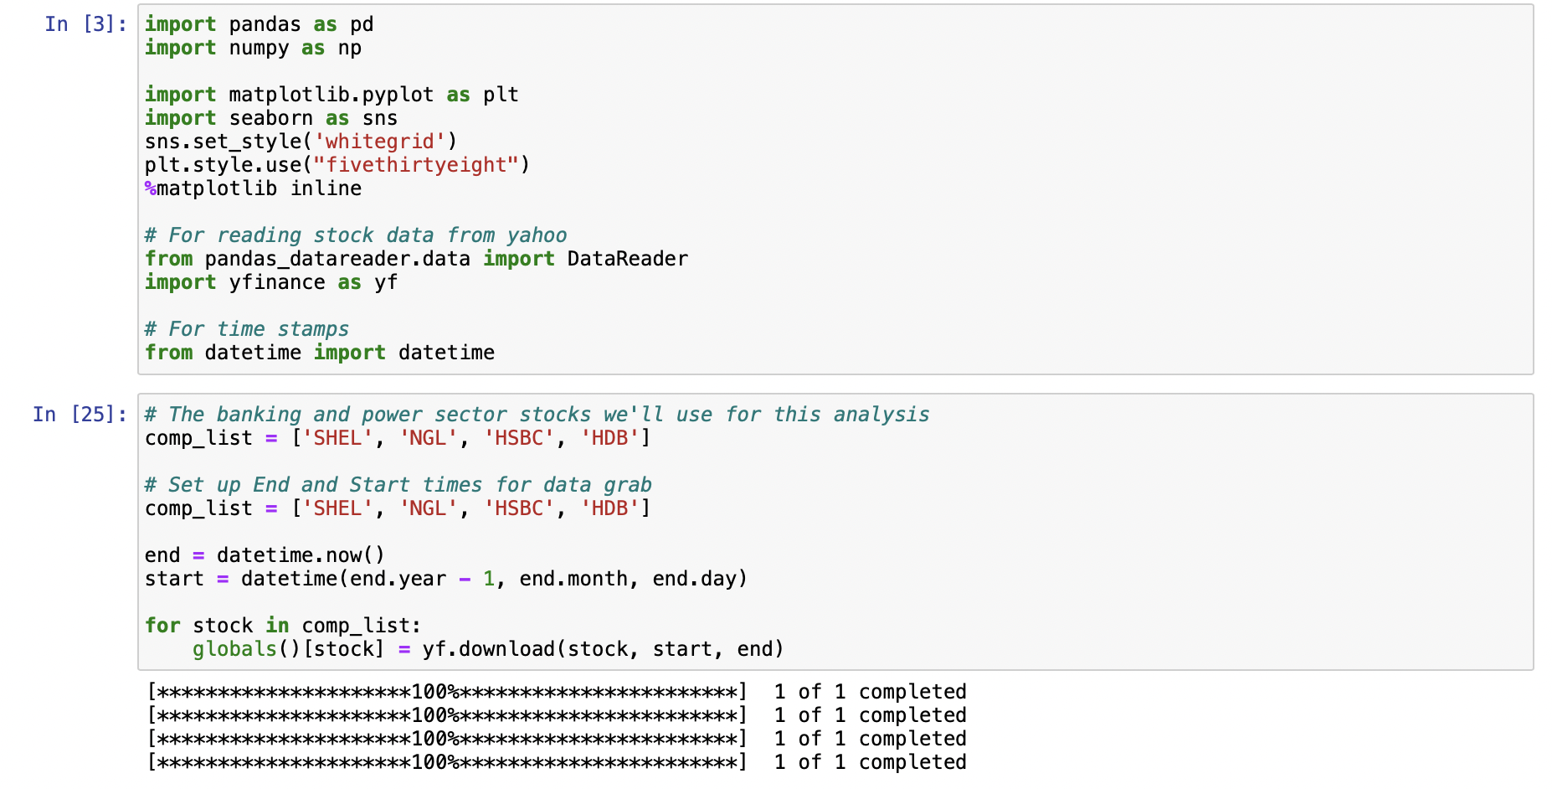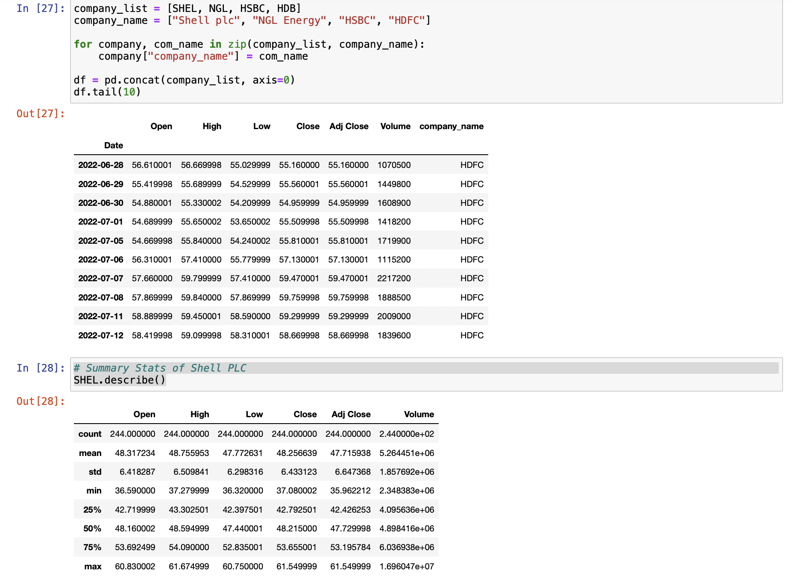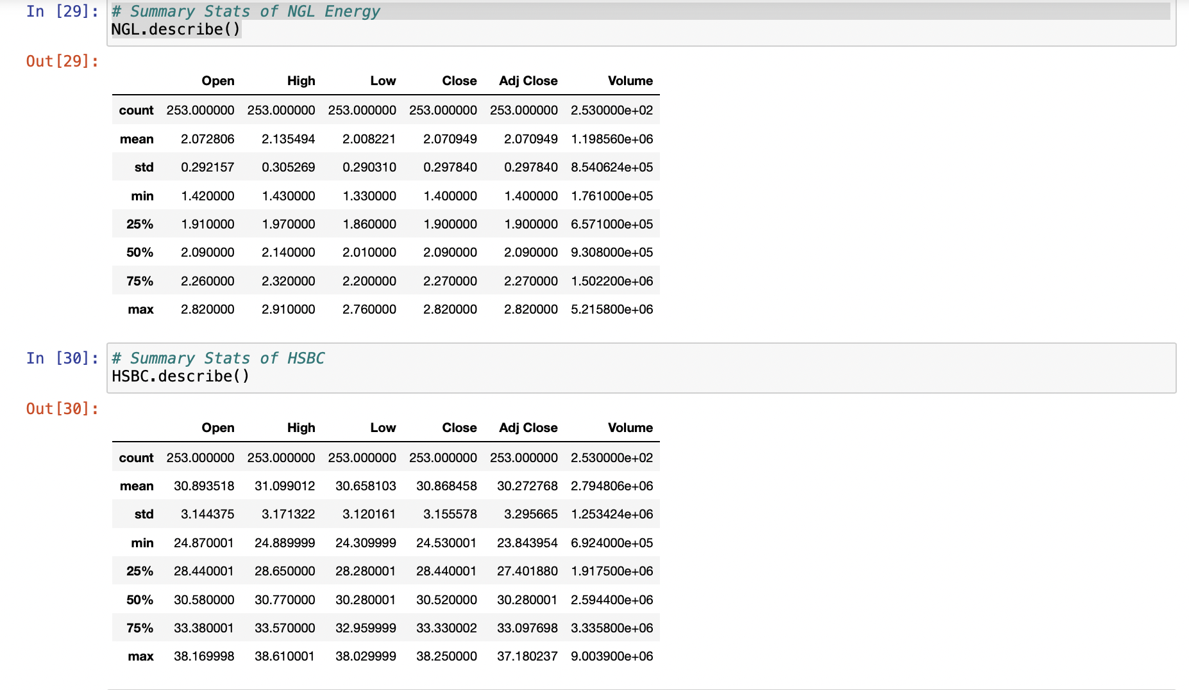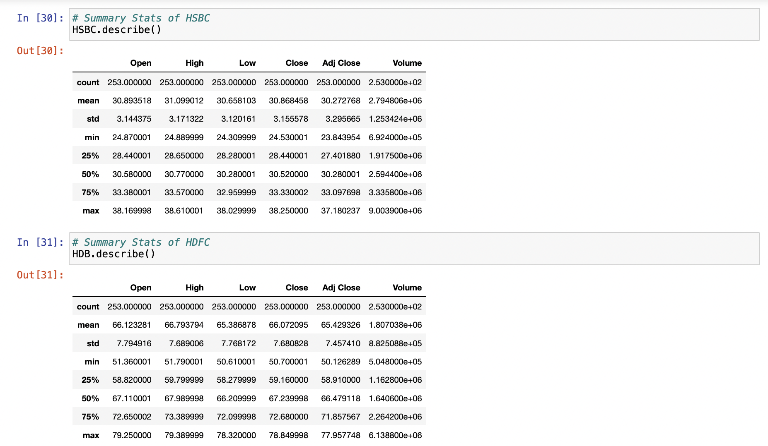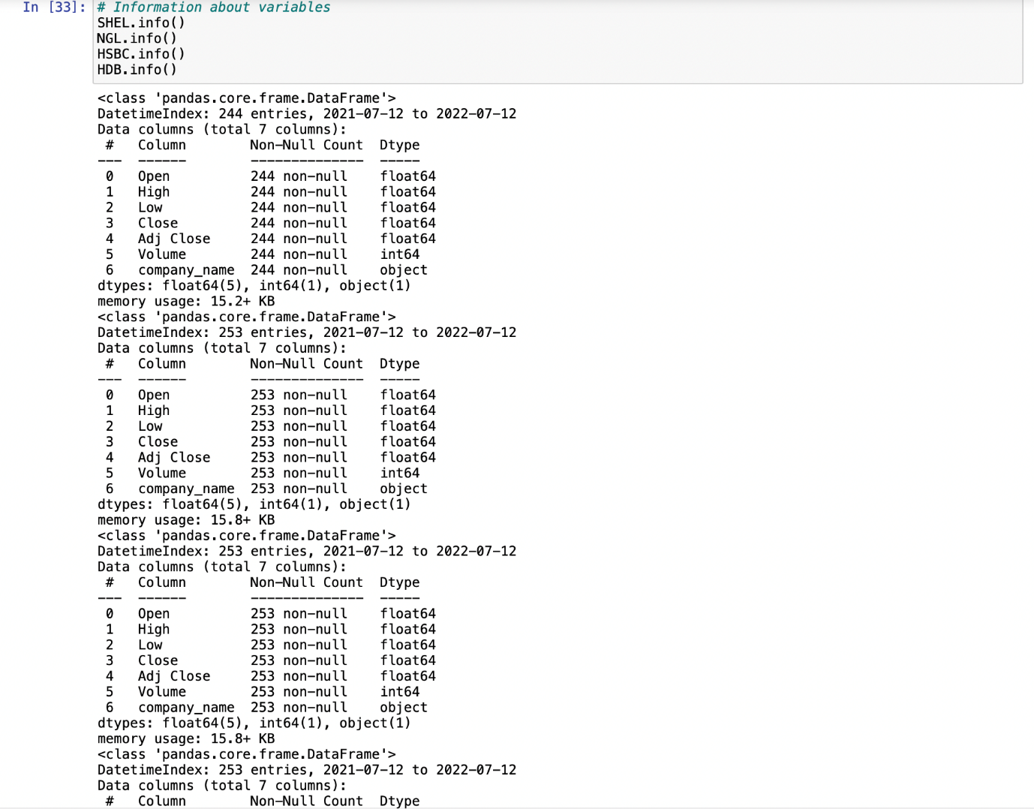

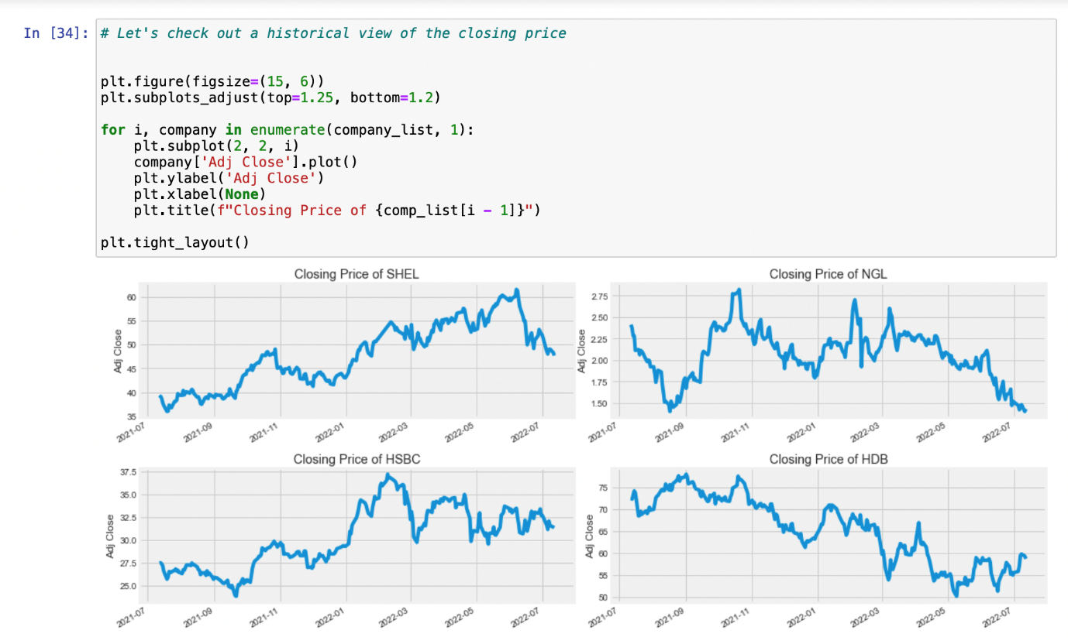

# **Appendices 2**

# 

# 

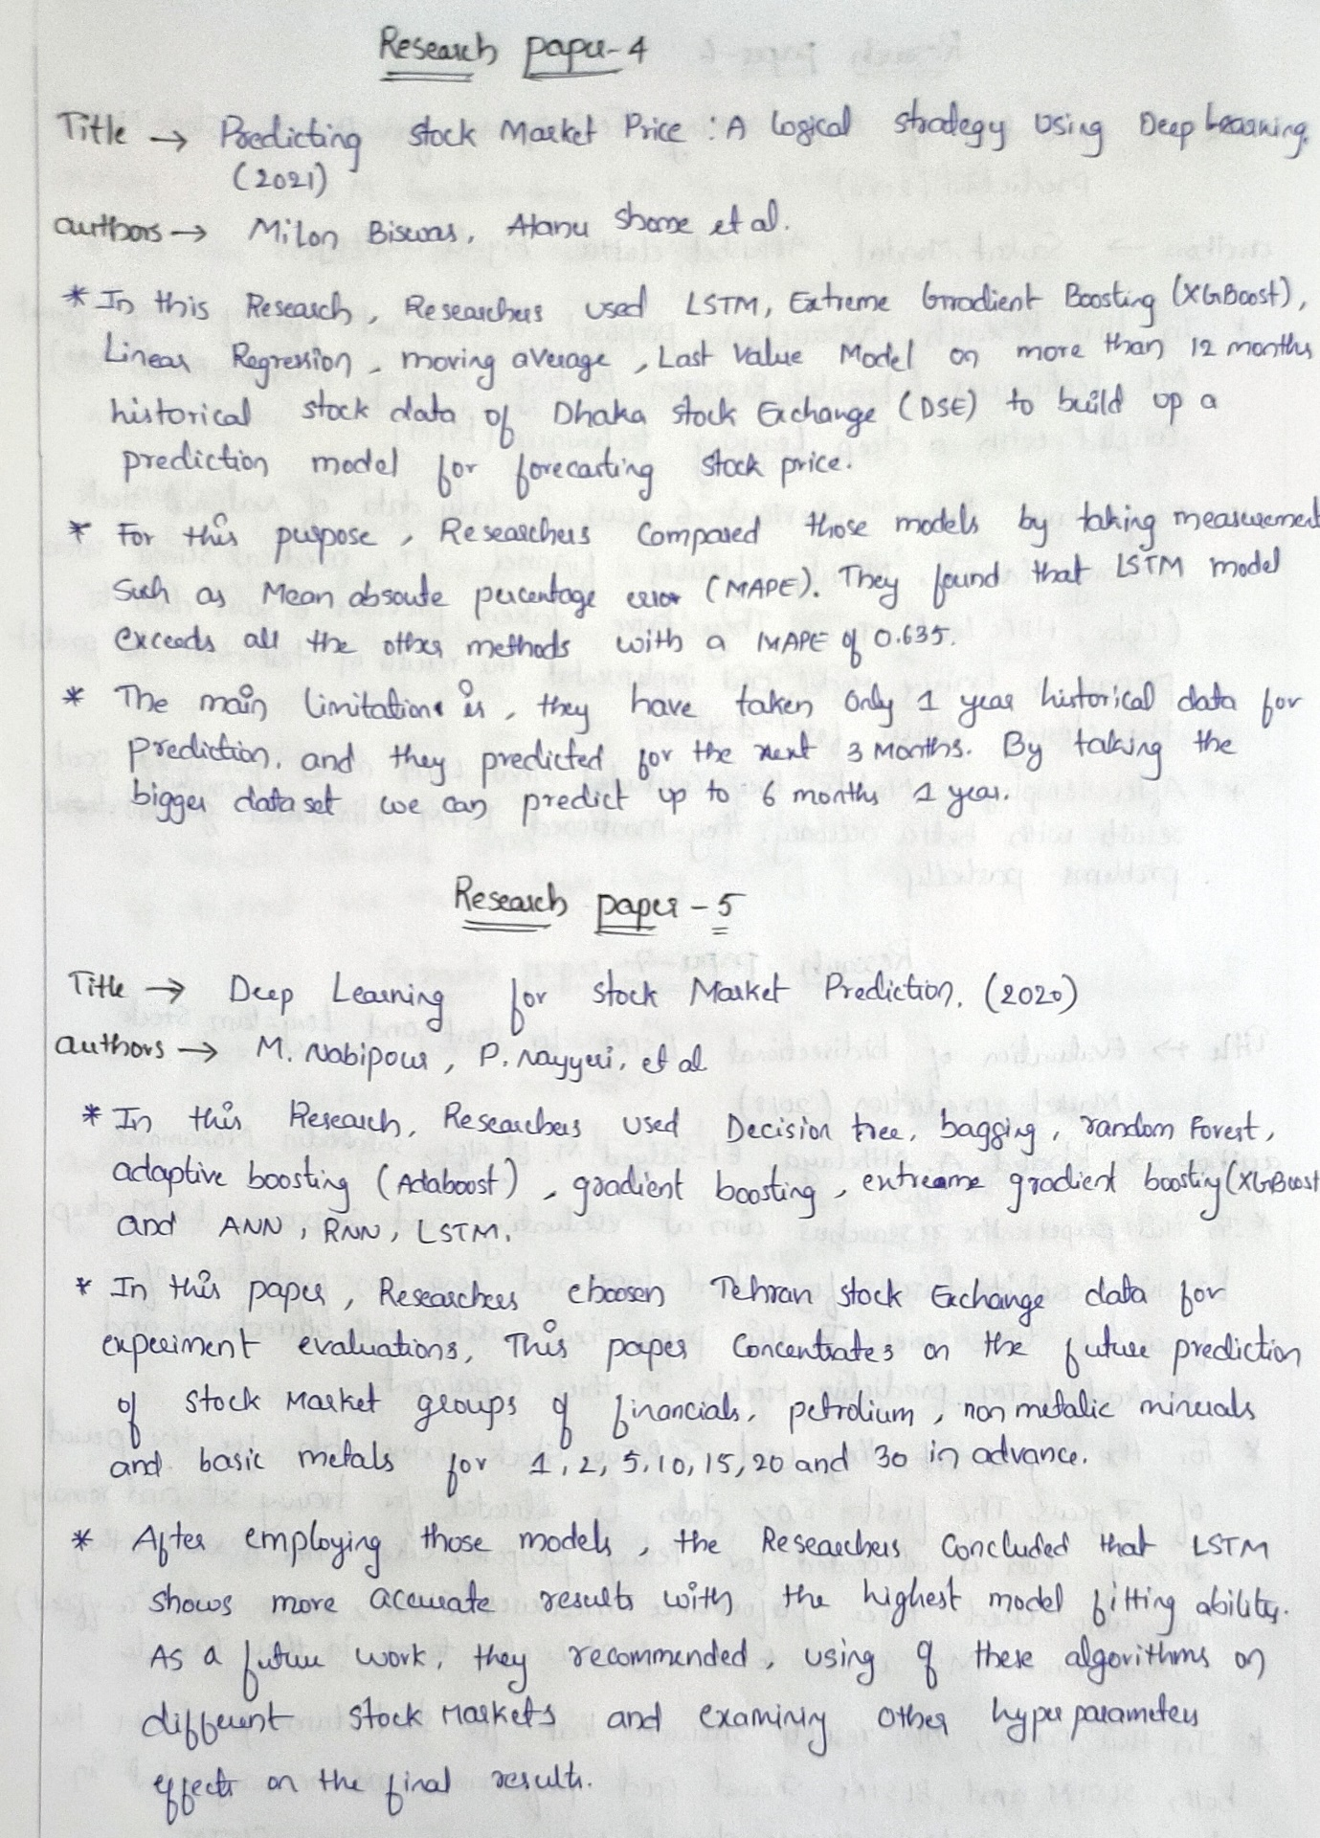

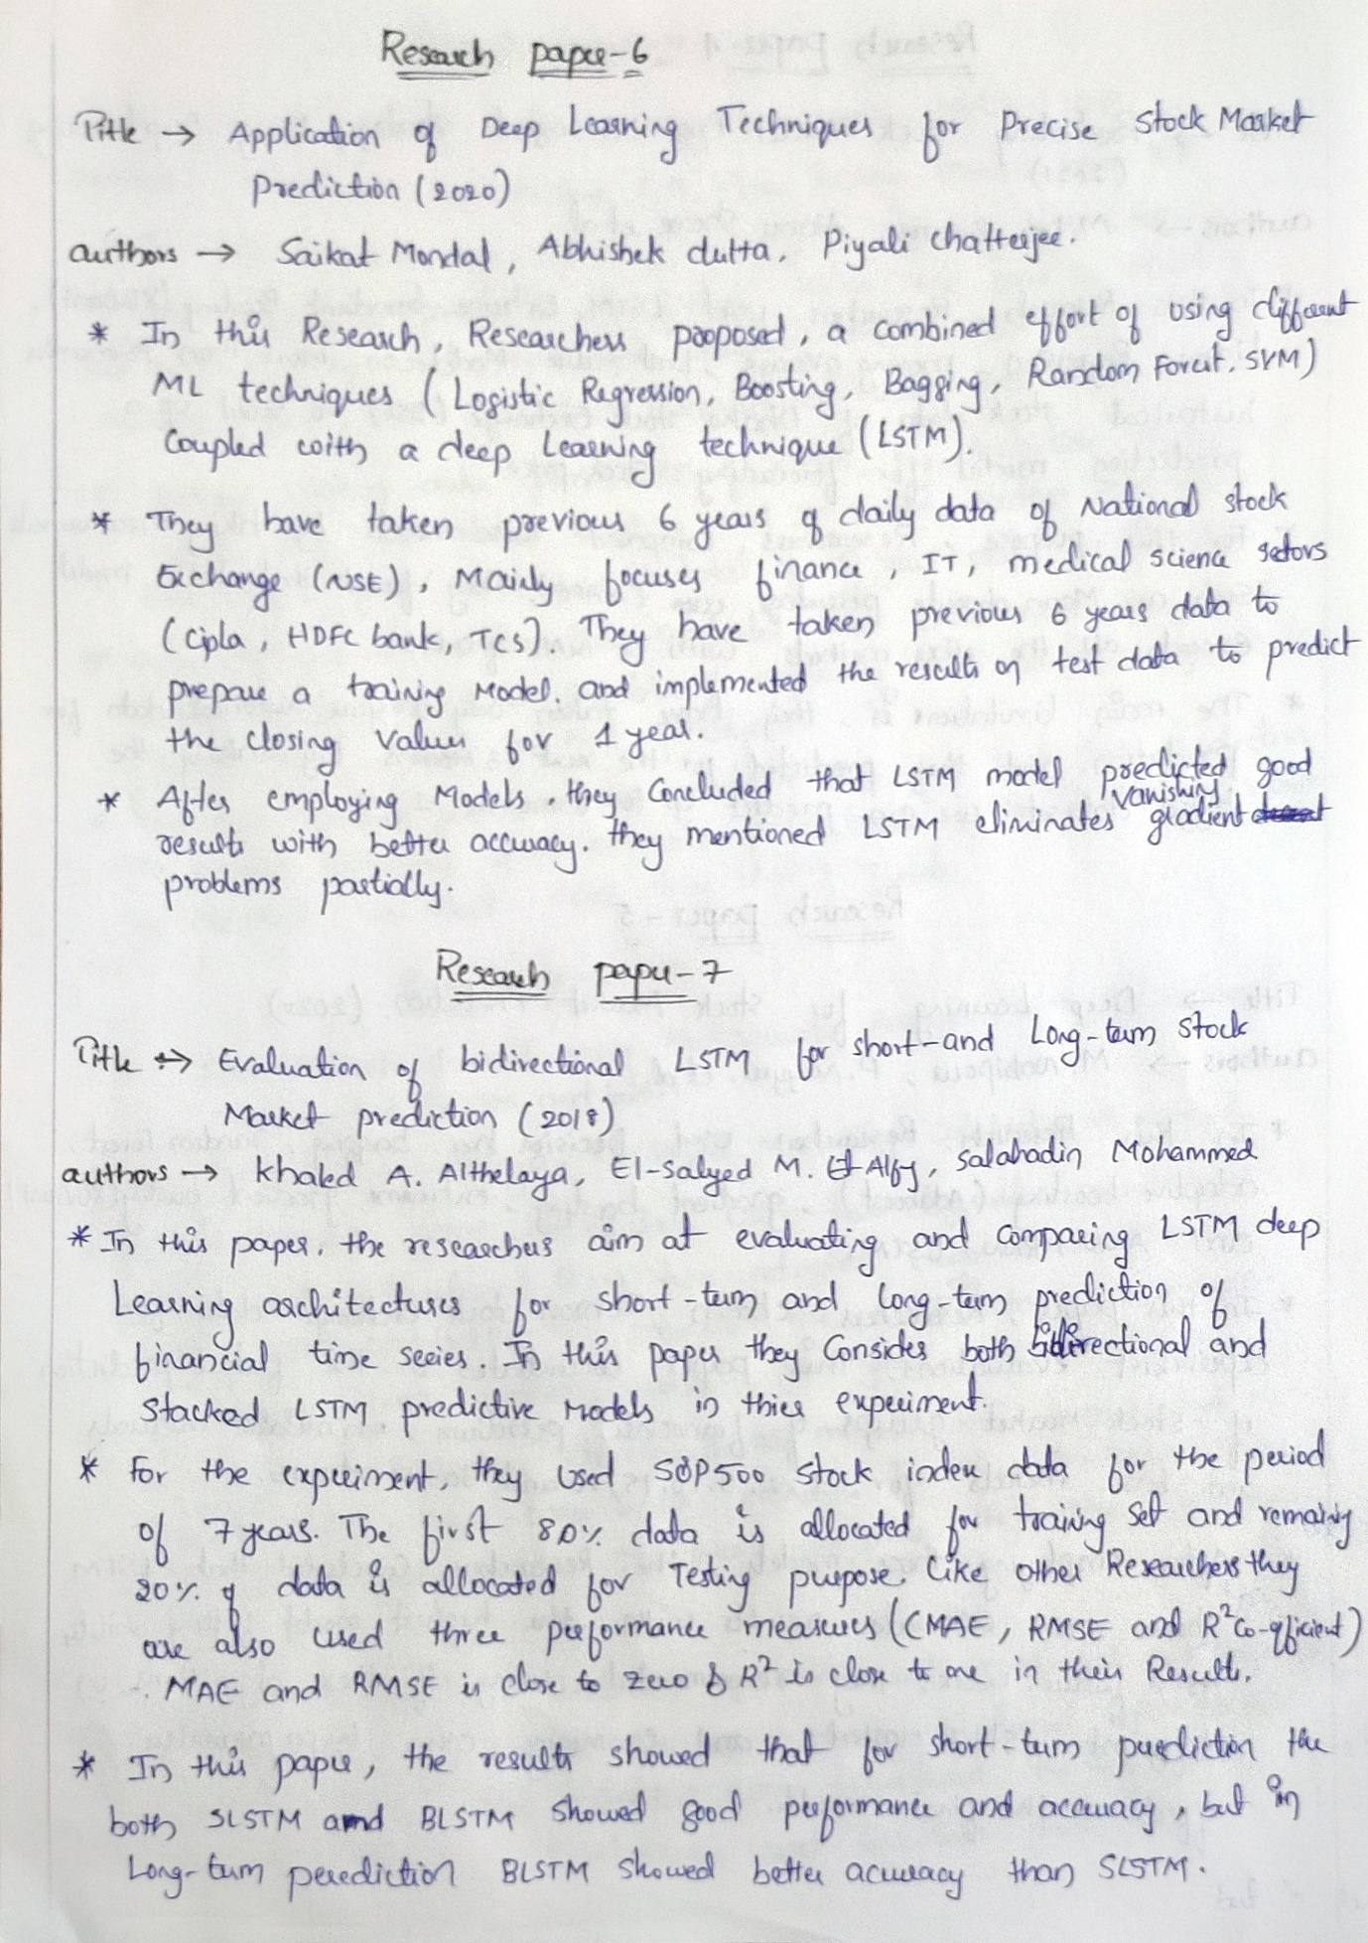

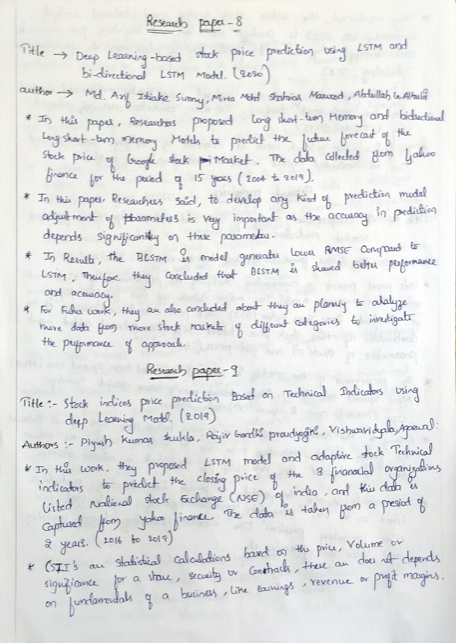

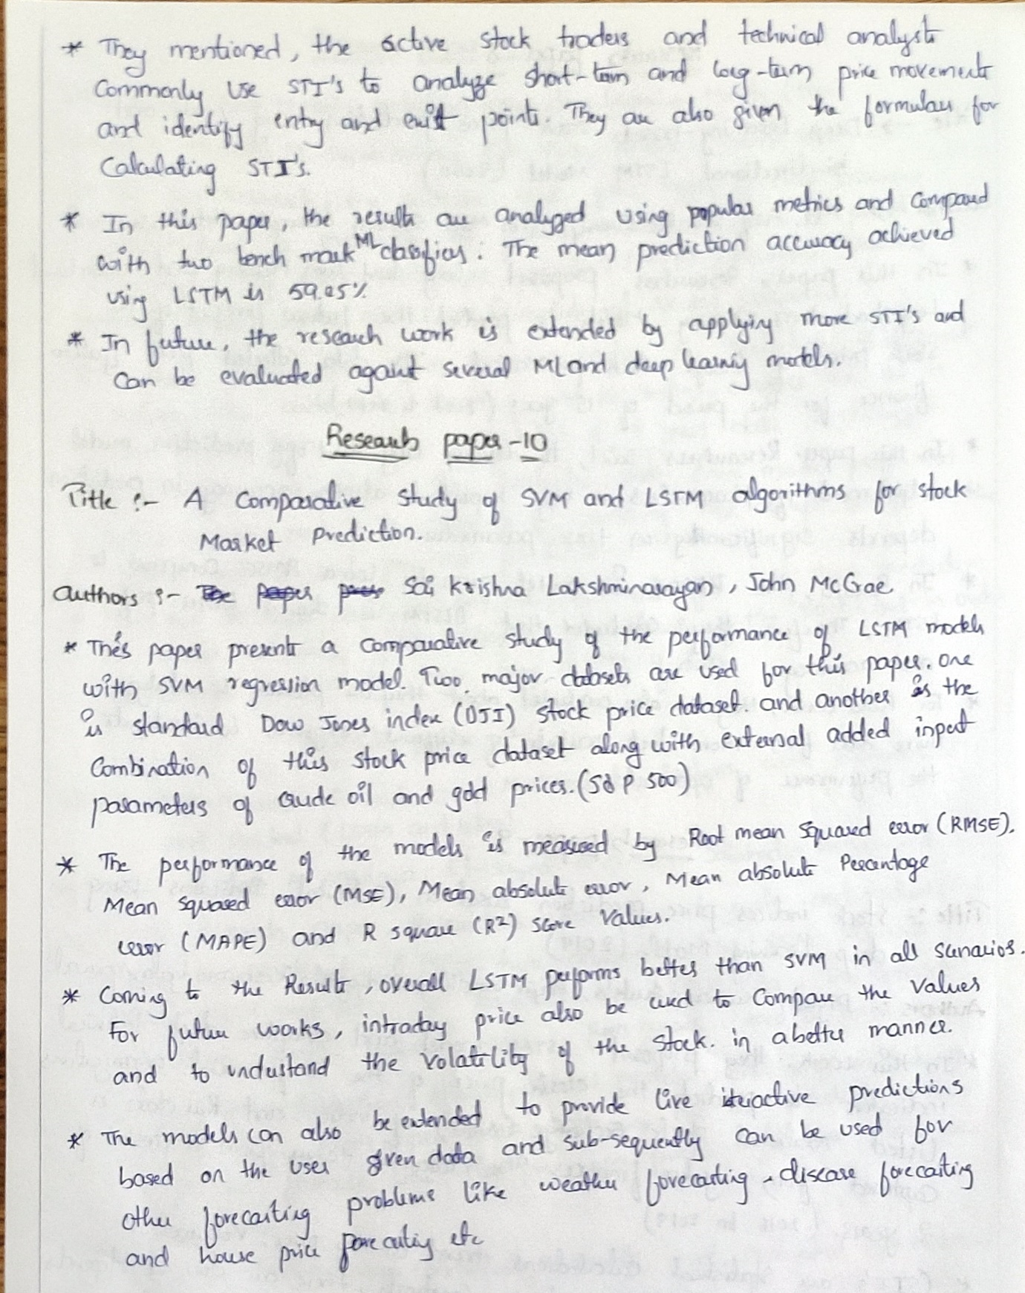

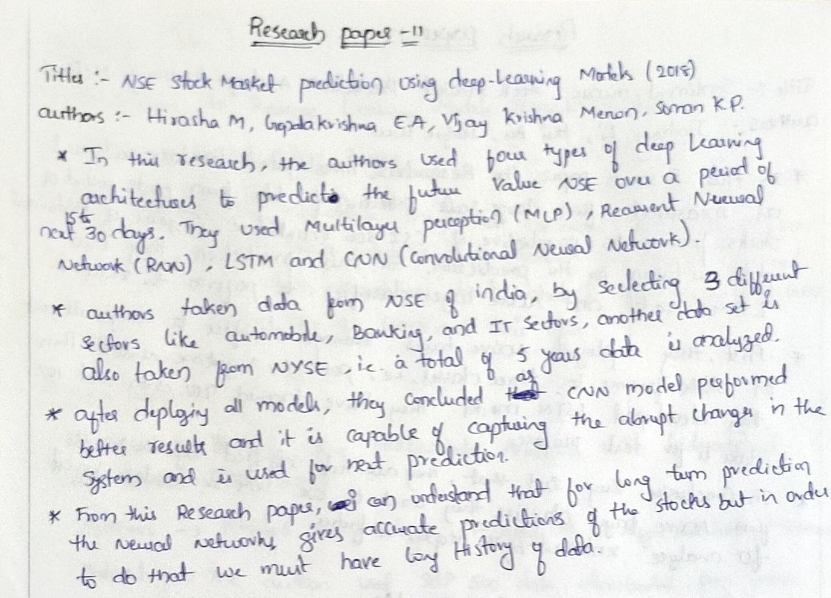

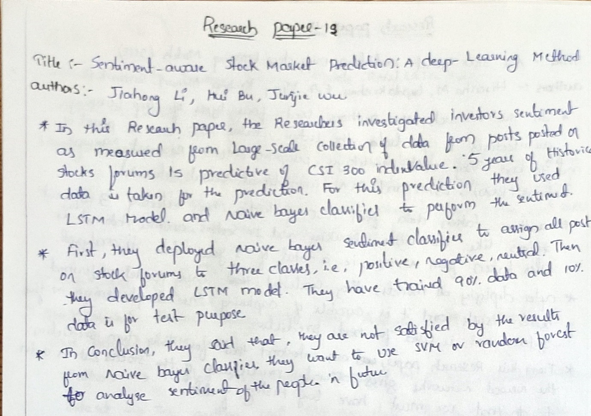

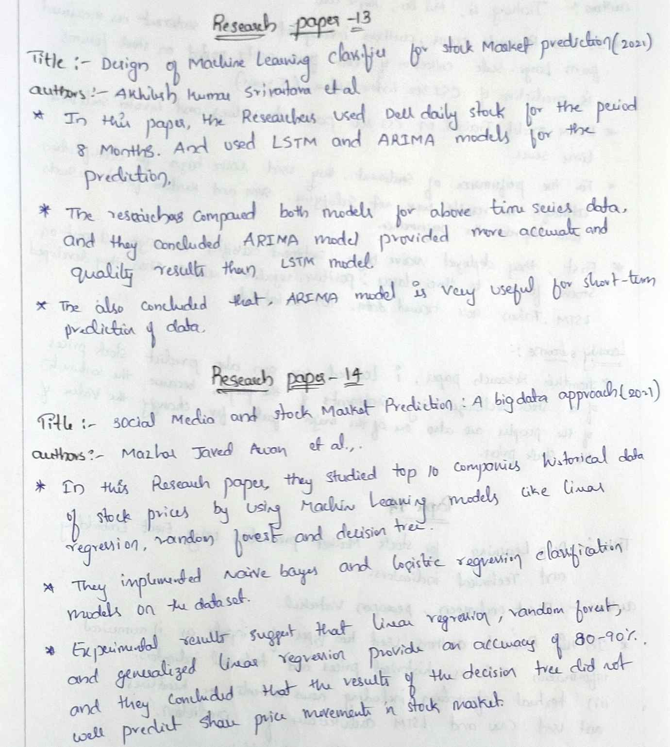

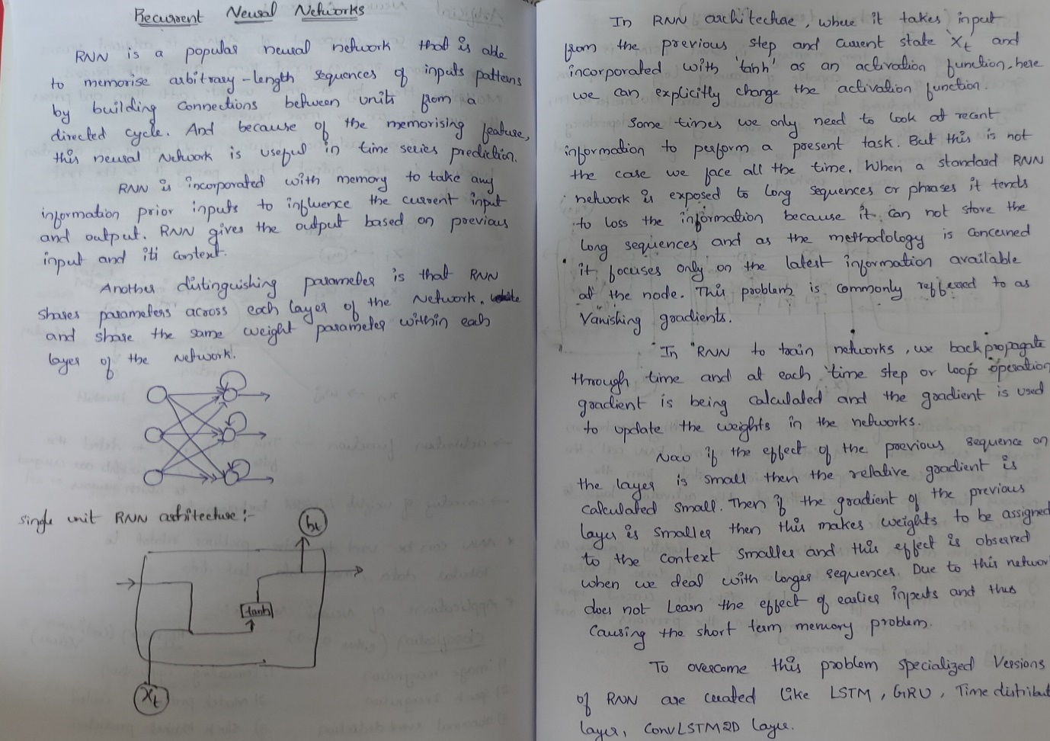

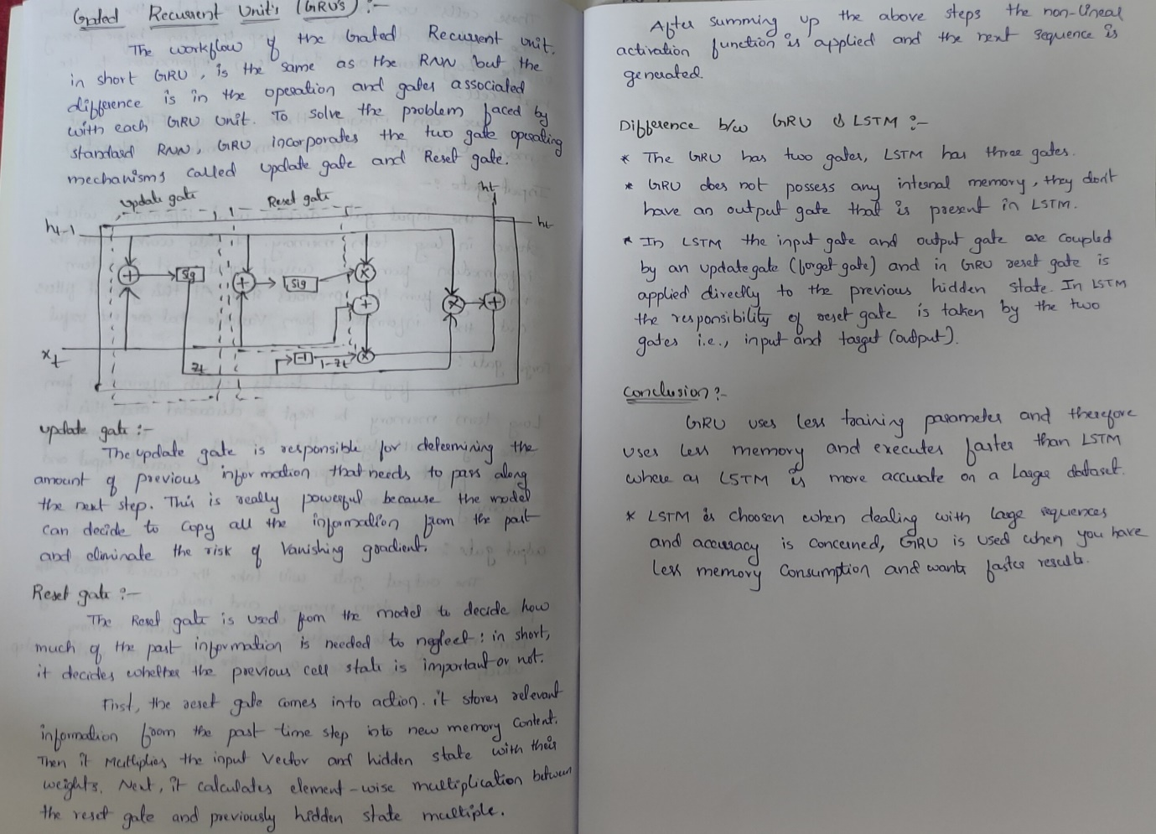

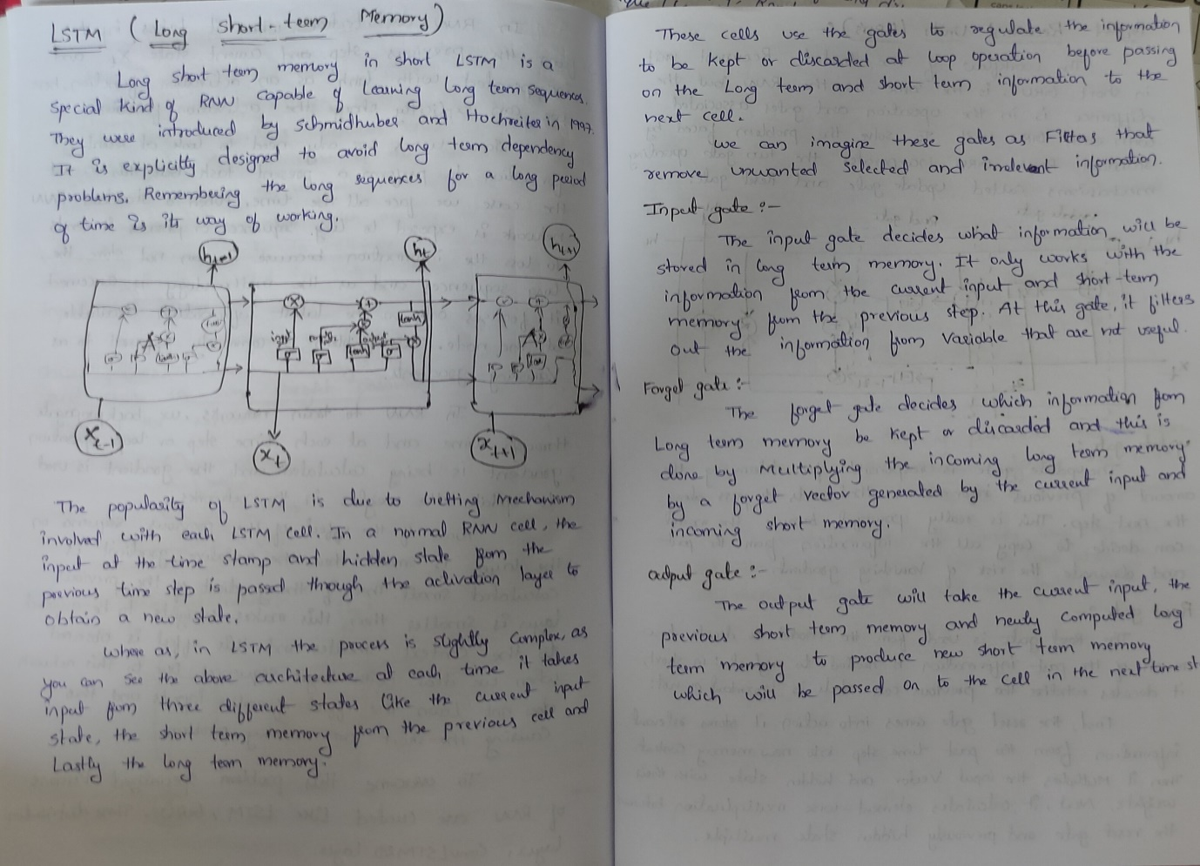

# **Appendices 3**

# 

